TASK 6 - WAN Technologies

- Create a table comparing Authentication, Authorization, and Accounting (AAA) by listing at least two real-world examples of each function from popular apps like Instagram, Zomato, or Paytm.
Ans.
Comparison of Authentication, Authorization, and Accounting (AAA)
AAA Function | Description | Real-World Example 1 | Real-World Example 2
Authentication | Verifies the identity of a user before allowing access. | Instagram: User enters username and password to log in. | Paytm: User enters mobile number and OTP to access the account.
Authorization | Determines what actions or resources a user is allowed to access. | Instagram: Users can edit only their own profile and posts. | Zomato: Restaurant owners can manage their restaurant menu, but cannot modify other restaurants' data.
Accounting | Records and tracks user activities for monitoring and security purposes. | Instagram: Records login history, likes, comments, and posts. | Paytm: Records transaction history, payment details, and login activity.
Explanation

Authentication
- Authentication confirms that the user is genuine before granting access. For example, Instagram requires a username and password, while Paytm uses OTP verification.

Authorization
- Authorization controls what a user can do after logging in. For example, Instagram users can manage only their own accounts, and Zomato restaurant partners can access only their own business information.

Accounting
- Accounting keeps records of user activities. Instagram stores login and activity logs, while Paytm maintains transaction and payment records for security and auditing purposes.
- Draw a simple network diagram showing how AAA is used to secure access to a WiFi network in a college campus, labeling where authentication, authorization, and accounting take place.
Ans. 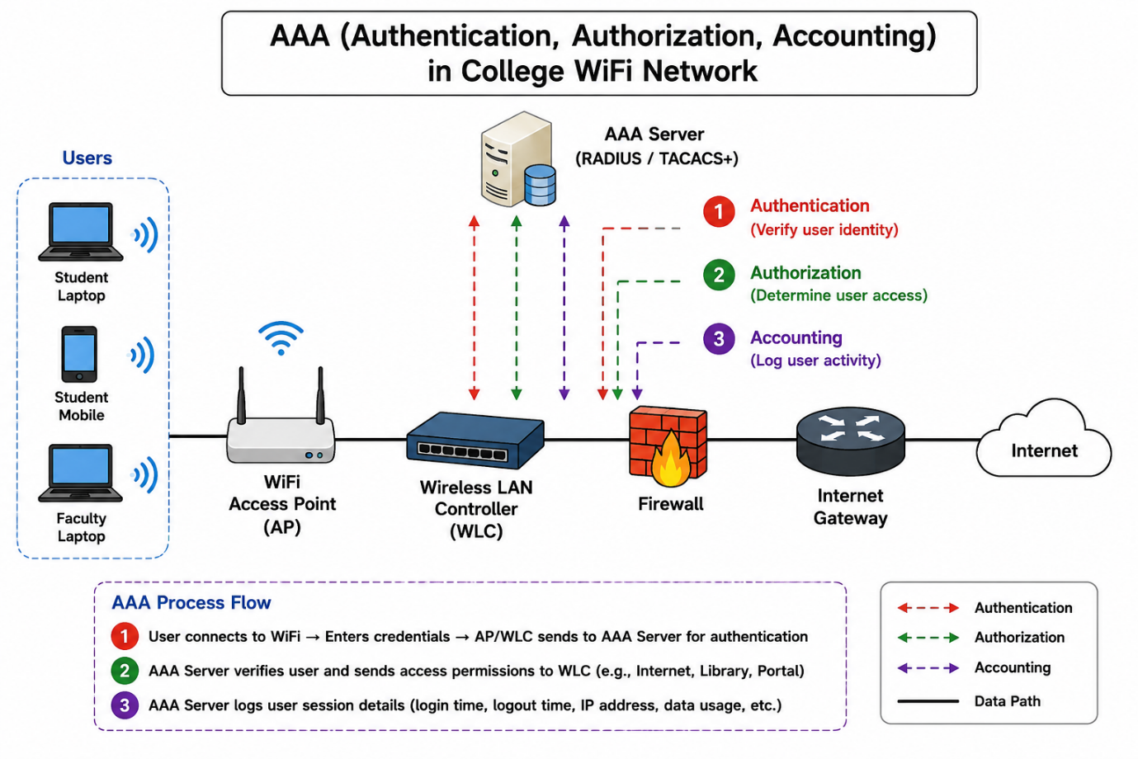

Explanation
The diagram shows how AAA (Authentication, Authorization, and Accounting) is used to secure a college WiFi network.

- Authentication: When a student or faculty member connects to the WiFi network, the Access Point sends the username and password to the AAA Server for verification.
- Authorization: After successful authentication, the AAA Server determines what resources the user is allowed to access, such as the internet, student portal, or library services.
- Accounting: The AAA Server records user activities such as login time, logout time, IP address, and data usage for monitoring and security purposes.

This process ensures that only authorized users can access the college WiFi network while maintaining security and activity logs.

- Explain the difference between centralized and distributed AAA deployment models by describing how each would work in a scenario where multiple Flipkart warehouses need secure network access.
Ans.
Centralized vs Distributed AAA Deployment for Flipkart Warehouses
Feature | Centralized AAA | Distributed AAA
AAA Server Location | One central AAA server at Flipkart's main data center. | Separate AAA servers at each warehouse location.
Authentication Process | All warehouses send login requests to the central AAA server. | Each warehouse authenticates users using its local AAA server.
Management | Easier to manage because policies are controlled from one location. | More complex because policies must be managed on multiple servers.
Availability | If the central server fails, authentication may be affected for all warehouses. | If one local server fails, only that warehouse is affected.
Cost | Lower infrastructure cost. | Higher cost due to multiple AAA servers.

Scenario: Centralized AAA
- Flipkart has warehouses in Ahmedabad, Mumbai, Bangalore, and Delhi. When an employee logs into the warehouse WiFi or inventory management system, the login request is sent to a central AAA server located at Flipkart's main data center in Bangalore. The server verifies the user's credentials, grants appropriate access, and records login activity.
Benefit:
- All user accounts and security policies are managed from one place, making administration easier.

Scenario: Distributed AAA
- Each Flipkart warehouse has its own local AAA server. When an employee in Ahmedabad logs in, the request is processed by the Ahmedabad AAA server instead of being sent to Bangalore. The same happens independently at the Mumbai, Bangalore, and Delhi warehouses.
Benefit:
- Authentication is faster and can continue even if the connection to the main data center is unavailable.

- Pick any one AAA deployment model and list three advantages and two disadvantages of using it for a large-scale app like BookMyShow.
Ans. AAA Deployment Model Chosen: Centralized AAA
- For a large-scale app like BookMyShow, a centralized AAA model uses one main AAA server to manage user authentication, authorization, and accounting for all users.

Advantages
1. Easier Management
- All user accounts, permissions, and security policies are managed from a single location. This makes administration simpler and ensures consistent security across the platform.
2. Better Security Control
- Security policies can be updated centrally. If BookMyShow wants to enforce stronger passwords or multi-factor authentication, the change can be applied to all users at once.
3. Centralized Monitoring and Logging
- All login attempts and user activities are stored in one place. This helps detect suspicious activities, generate reports, and improve security monitoring.

Disadvantages
1. Single Point of Failure
- If the central AAA server becomes unavailable, users may face difficulties logging in to the BookMyShow app or website.
2. Higher Network Dependency
- All authentication requests must reach the central server. Network issues or high traffic can cause delays in user login and access.

- Use ChatGPT or another AI tool to generate a sample AAA policy for a Zomato-like app, specifying what actions are authenticated, which roles are authorized for each action, and what accounting logs should be kept. Paste the generated policy and highlight one thing you would change to make it more secure.
Ans.
Sample AAA Policy for a Zomato-Like App
1. Authentication Policy
The following actions require user authentication:
- User login using email/mobile number and password.
- OTP verification during login or account recovery.
- Restaurant partner login to manage menus and orders.
- Delivery partner login to access delivery assignments.
- Admin login to access the management dashboard.
2. Authorization Policy
- Role- Authorized Actions
- Customer- Browse restaurants, place orders, make payments, track orders, write reviews.
- Restaurant Partner- Update menu, accept/reject orders, view sales reports.
- Delivery Partner- View assigned deliveries, update delivery status, contact customers.
- Admin- Manage users, restaurants, delivery partners, promotions, and system settings.

3. Accounting Policy
The system should log:
- User login and logout time.
- Failed login attempts.
- Order placement and cancellation records.
- Payment transactions.
- Menu updates by restaurant partners.
- Delivery status updates.
- Admin actions such as account modifications and policy changes.
- IP address and device information used during login.
- One Security Improvement

Current Policy: Users log in with only a password or OTP.

- Suggested Change: Enable Multi-Factor Authentication (MFA) for restaurant partners and administrators.

- Reason: Even if a password is stolen, an attacker would still need the second authentication factor (such as an OTP or authenticator app code), making unauthorized access much more difficult.

